

D.K.T.E Society’s

Textile and Engineering Institute, Ichalkaranji

(An Autonomous Institute Affiliated to Shivaji University Kolhapur)

**Department of Electronics and Telecommunication Engineering**

**A Mini Project Report on**

**LASER TRIPWIRE ALARM USING ARDUINO UNO**

**By**

**ATHARV MAHADEO JAMKHINDIKAR PRN NO.: 21UET044**

**RAJBHUSHAN KAMALAKAR KADAM PRN NO.: 21UET046**

**RUSHIKESH SANJAY KAMATE PRN NO.: 21UET052**

**Under Guidance of**

**Y. V. SAWANT**

**Academic Year**

**2022-2023**



D.K.T.E Society’s

Textile and Engineering Institute, Ichalkaranji

(An Autonomous Institute Affiliated to Shivaji University Kolhapur)

Department Of Electronics and Telecommunication Engineering

Academic Year 2022-2023

Certificate

This is to certify that.

**ATHARV MAHADEO JAMKHINDIKAR 21UET044**

**RAJBHUSHAN KAMALAKAR KADAM 21UET046**

**RUSHIKESH SANJAY KAMATE 21UET052**

of Second Year B. Tech [EXTC] has satisfactorily completed mini project entitled

**LASER TRIPWIRE ALARM USING ARDUINO UNO** for partial fulfilment of Under Graduation in Electronics and Telecommunication Engineering at D.K.T. E’s Textile and Engineering Institute, Ichalkaranji for Academic Year 2022-2023**.**

Prof. Y. V. Sawant Prof. Dr. S.A. Patil Prof. (Dr.) L.S.Admuthe

**Guide Head of ETC Department Director**

**Table of Contents**

**Chapter 1: Introduction**

**Chapter 2: System Implementation**

* 1. Block Diagram with Explanation
  2. Circuit Diagram
  3. Description of Hardware Components

**Chapter 3: Arduino Code**

**Chapter 4: Conclusion**

**Chapter 5: Applications with Advantages and Limitations**

* 1. Applications
  2. Advantages
  3. Limitations

**Chapter 6: References 0**

**Chapter-I**

**INTRODUCTION**

Security is a most important factor today. Technology develops day by day in the world which also makes us vulnerable against people with criminal intent. So, we decide to make a security project as our project.

In this project we have used laser light as a tripwire to trigger alarm. We know laser light goes through long distance without scattering effect. It’s also visible only at source and incident point, otherwise invisible. These two properties help us to build up a modern security system, which may name as “laser security alarm”.

When any person or object crossover the laser line it will trigger an alarm to warn us about any intrusion. There will be two parts in the system. One is transmitter and other is receiver where Laser Emitter a transmitter will transmit a laser beam to the light sensor a receiver, and when someone/something passes, the sensor won't receive the beams, and the alarm is triggered, and won't stop until you reset it by pushing button or by entering passcode. We can also make a security boundary of single laser light by using mirror at every corner for reflection and can cover a large area.

**Chapter 2**

**SYSTEM**

**IMPLEMENTATION**

* **Block Diagram with Explanation:**

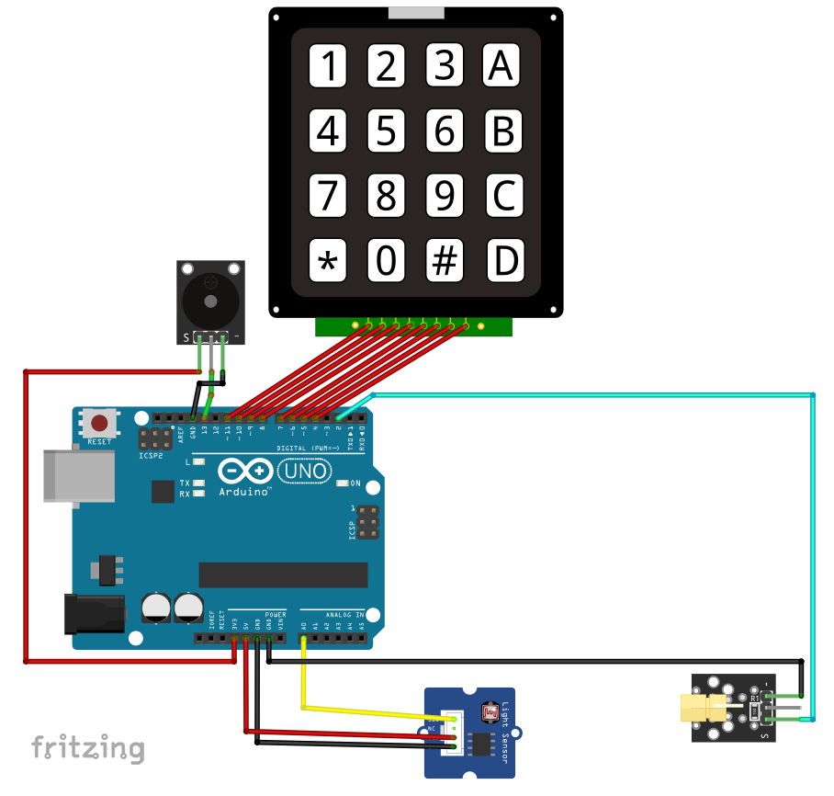

A tripwire is a device triggered by physical movements, you can use it to detect people, animals, cars... when they pass through an area. This one is based on a LASER emitter, that constantly sends beams to the light sensor, and when someone/something passes, the sensor won't receive the beams, and the alarm is triggered, and won't stop until you reset it (push button/passcode).

The passcode is stored in an array, we choose 4 digits code, but anyone can make it longer or shorter, just modify the array size, and add or remove values.

To turn the alarm off, you should press ‘*’ on the keypad, then enter the numbers **0, 8, 0, 3,** the code will fix the buzzer in a single frequency (disturbing) sound until you enter 4 digits, if they are correct the alarm will stop, otherwise it will go off again.

Every time you enter a correct digit “a” value increases, if it’s == 4, the code is considered correct, otherwise the number will never be equal to 4.

**Here is a small explanation for how code works….**

1. The code starts by defining the pins for the LASER module (Laser), the LDR sensor (Rec), and the button (Button). It also defines a Boolean variable called detection to keep track of whether someone has triggered the alarm.
2. The code sets up the keypad with its rows and columns and initializes the keypad object.
3. In the setup function, the Laser pin is set as an output and set to HIGH. This prepares the LASER module for operation.
4. The main logic of the program is in the loop function. It reads the sensor value from the LDR sensor using the analogRead function. If the sensor value is below 500, it means that the LASER beams are interrupted, and detection is set to true.
5. If detection is true, the alarm sequence is triggered. The Arduino board produces a sound by toggling pin 13 between two frequencies using the tone function. The keypad is checked for the '' key. If the '' key is pressed, the program jumps to the Getpass function.
6. In the Getpass function, a constant frequency sound is produced to indicate that the user should enter the passcode. The passcode is entered by waiting for keypresses using the waitForKey function of the keypad object. Each entered digit is compared with the corresponding digit in the code array. If the entered sequence matches the code, the variable a is incremented. Once a reaches 4 (indicating that all digits were entered correctly), the alarm is turned off, and detection is reset to false.
7. The loop function continues to run, and the process repeats.

* + **Circuit Diagram:**



* + **Description of Hardware Components:**

1. **Arduino Uno Board**

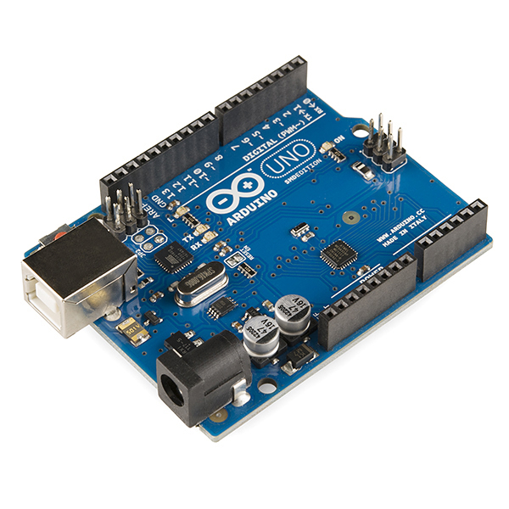

Arduino Uno is a microcontroller board based on the **ATmega328P** (datasheet). It has 14 digital input/output pins (of which 6 can be used as PWM outputs), 6 analog inputs, a 16 MHz ceramic resonator (CSTCE16M0V53-R0), a USB connection, a power jack, an ICSP header and a reset button. It is programmed based on IDE, which stands for Integrated Development Environment. It can run on both online and offline platforms. The [**IDE**](https://www.javatpoint.com/arduino-ide)is common to all available boards of Arduino.

The hardware structure of Arduino Uno

1. Microcontroller 2. 14 Digital Pin

3. 6 Analog Pins 4. Power Supply

5. Power Jack 6. USB Port

7. Reset Button

1. **LDR Sensor Module**

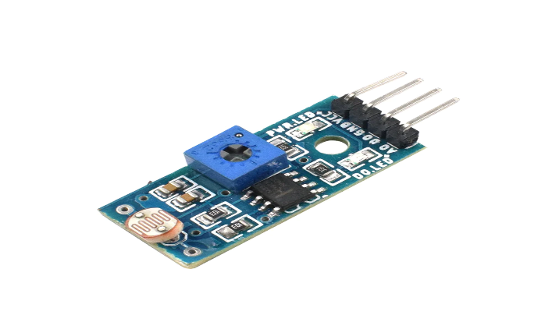

The LDR Sensor Module is used to detect the presence of light / measuring the intensity of light. The output of the module goes high in the presence of light, and it becomes low in the absence of light. The sensitivity of the signal detection can be adjusted using a potentiometer.

LDR sensor modules are used where there is a need to sense the presence and absence of light is necessary. These resistors are used as light sensors and the applications of LDR mainly include alarm clocks, streetlights, light intensity meters, and burglar alarm circuits.

**Features:**

* Can detect ambient brightness and light intensity.
* Adjustable sensitivity (via blue digital potentiometer adjustment)
* Operating voltage 3.3V-5V
* Output Type
* Analogue voltage output - A0
* Digital switching outputs (0 and 1) -D0
* Small board PCB size: 3cm * 1.6cm

1. **Laser Emitter**

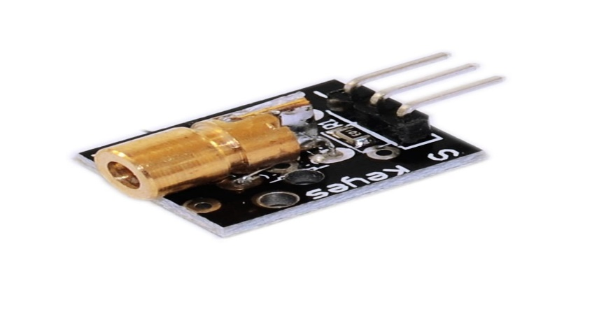

A laser diode, injection laser diode, or diode laser is a semiconductor device like a light-emitter in which a diode pumped directly with electrical current can create lasing conditions at the diode's junction. Laser diodes can directly convert electrical energy into light.

The KY-008 Laser transmitter module consists of a **650nm red laser diode head** and a resistor.

* Operating Voltage 5V
* Output Power 5mW
* Wavelength 650nm
* Operating Current less than 40mA
* Working Temperature -10°C to 40°C

1. **Buzzer**

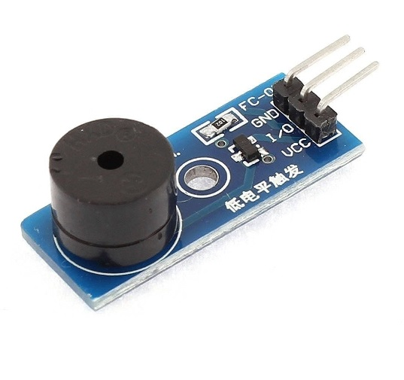

A buzzer or beeper is an audio signalling device, which may be mechanical, electromechanical, or piezoelectric (piezo for short). Typical uses of buzzers and beepers include alarm devices, timers, and confirmation of user input such as a mouse click or keystroke. An Active Buzzer Alarm Module for Arduino is an audio signalling device, which may be mechanical, electromechanical, or piezoelectric.

1. **Keypad Matrix**

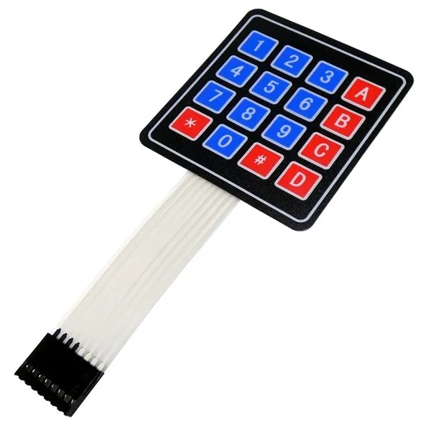

A Matrix keypad is the most used input device in many of the application areas like digital circuits, telephone communications, calculators, ATMs, and so on. A matrix keypad consists of a set of push-button or switches which are arranged in a matrix format of rows and columns.

1. **Battery (9V)**

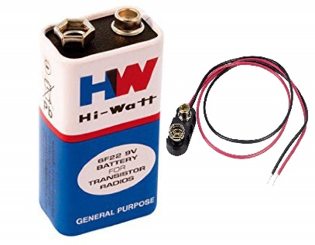

The **nine-volt battery**, or **9-volt battery**, is an [electric battery](https://en.wikipedia.org/wiki/Electric_battery) that supplies a nominal voltage of 9 [volts](https://en.wikipedia.org/wiki/Volt). Actual voltage measures 7.2 to 9.6 volts.

**Chapter 3**

**ARDUINO CODE**

#include <Keypad.h>

#define Rec A1

#define Laser 2

#define Button 3

bool detection;

short a=0;

short code[4]={'0','8','0','3'};  //pass code stored in a array you can make it longer or shorter

                                  //by changing '4' and add/remove values

const byte numRows= 4;            //Rows and columns of the keypad

const byte numCols= 4;

char keymap[numRows][numCols]=    //Keypad map

          {

          {'1', '2', '3', 'A'},

          {'4', '5', '6', 'B'},

          {'7', '8', '9', 'C'},

          {'*', '0', '#', 'D'}

          };

byte rowPins[numRows] = {11,10,9,8}; //Keypad 8 pins

byte colPins[numCols]= {7,6,5,4};

Keypad myKeypad= Keypad(makeKeymap(keymap), rowPins, colPins, numRows, numCols);

void setup() {

  Serial.begin(9600);

  pinMode(Laser, OUTPUT);

  digitalWrite(Laser, HIGH);

  delay(1000);

}

void loop() {

 short sensorValue = analogRead(A1);  // Read the input from the light sensor connected to analog pin A0

Serial.println(sensorValue);

    if(sensorValue > 1000)

        detection = true;

    if(detection==true)

        {                                       //Alarm sequence and constantly waiting for '*' to be pressed

         tone(13,1000);

         delay(50);

         tone(13,200);

         delay(50);

         char keypressed = myKeypad.getKey();

         if (keypressed == '*')                   //if '*' is pressed go to Getpass function

         Getpass();

          }

     if(a==4){                                   //if a==4 means the code is correct, the alarm is off

         noTone(13);

         a=0;                                   //setting the a to 0, otherwise the alarm will turn off automatically

         detection=false;

        noTone(13);

         }

}

void Getpass(){               //Getting passcode function

  tone(13,2000);              //Constant frequency sound while entring the code

  for(short i=0 ; i<4 ; i++)

            {

           char keypressed = myKeypad.waitForKey();

              if (keypressed==code[i])   //If the sequence is correct the a increases (4) means all values are right

              a++;

            }

}

**Chapter 4**

**CONCLUSION**

The objective of the Laser-based Security alarm system is the same as its name suggests that is it will keep measuring the light coming from the Laser light using LDR, and the Arduino UNO MCU will check for the intensity to decrease from its initial value indicating obstacle between Laser light and LDR. And when the situation arises, Arduino will close the circuits for various buzzers and LEDs.

This project deals with a model of laser security alarm system design. Laser through long distance without any scattering effect and it is only visible at source and the destination point so it can be used as a mediator between source and destination but to analyse the source a sensor is needed, here the use of LDR is applicable. Just analysis is not enough alerting should be done in general alerting is the sound effect so here buzzer act as alerting. Making use of this, a laser security system is designed.

**Chapter 5**

**APPLICATIONS WITH ADVANTAGES**

**AND LIMITATIONS**

* **Applications:**
  + A laser security system can be used in bank vaults or at any entrance of home or any important locations to provide extra layer of security.
  + It can also be used as a fence in huge fields where concrete or wooden fence can’t be installed.
  + In security alarm systems, lasers serve to provide stealthy home security that's hard for burglars to get past.
* **Advantages:**
* This is very simple, construction and setup for the Laser Security System are very simple.
* We have used a battery as a power supply, and the laser security system can work even when there is a power outage.
* It can be made at home with simple available components.
* Laser light can be diverted through simple mirrors to protect more areas.
* **Disadvantages:**

The laser security system alarm works only if the laser light is disturbed by crossing its light. If anyone crosses the protected area without obstructing the laser, it is considered a failure.

**Chapter 6**

**REFERENCES**

* 1. <https://www.google.com/search?q=laser+security+system+applications&source=lmns&bih=688&biw=1536&hl=en&sa=X&ved=2ahUKEwj8wYSH0-P-AhVnF7cAHRwyCcUQ_AUoAHoECAEQAA>
  2. <https://www.flyrobo.in/blog/what-is-arduino-uno>
  3. <https://robocraze.com/blogs/post/how-ldr-sensor-works>
  4. <https://www.google.com/search?q=block+diagram+for+laser+trip+wire+alarm+using+arduino+uno&sxsrf=APwXEdcI9EdInawH-h7-zfEpEgAgB_sj9A:1683466200062&source=lnms&tbm=isch&sa=X&ved=2ahUKEwjR-uGmqOP-AhWg-TgGHai5BCEQ_AUoAXoECAEQAw&biw=1536&bih=746&dpr=1.25#imgrc=9a5OxovBoOyRRM>
  5. <https://how2electronics.com/laser-light-security-system-using-arduino/>

**THANK YOU….!**